1. Create a new table that consolidates information from multiple tables using DAX.

HealthExpenditureSummary = SUMMARIZE('Health Expenditure', Country[CountryID],'Year'[YearID], "Country_Name",max(Country[CountryName]), "Year", max('Year'[Year]), "Total_Expenditure", sum('Health Expenditure'[ExpenditureAmount]), "Total_GDP",sum(GDP[GDPAmount]), "Total_Population",sum(Population[PopulationCount]))

// This DAX function creates a table HealthExpenditureSummary. The preview of this table is shown below.

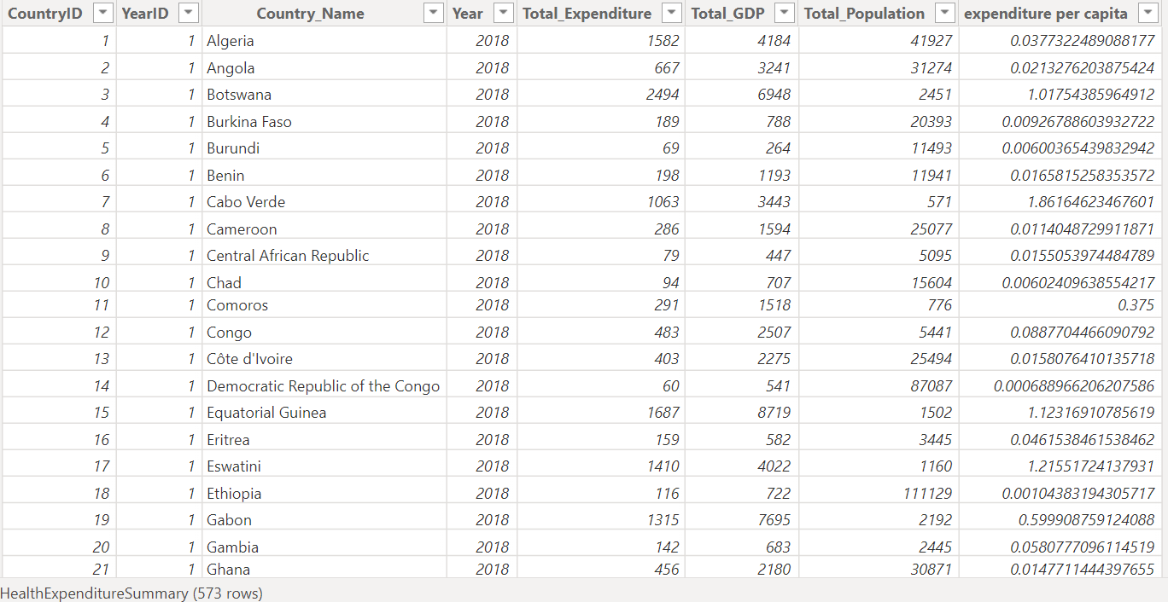

1. Find the countries/regions with the highest and lowest health expenditure for all years.

highest expenditure country = var max_expenditure = max(HealthExpenditureSummary[Total_Expenditure]) return CALCULATE(max(HealthExpenditureSummary[Country_Name]),filter(HealthExpenditureSummary,HealthExpenditureSummary[Total_Expenditure]=max_expenditure))

// This DAX function returns the country with the Highest Health Expenditure that is Monaco.

lowest expenditure country = var min_expenditure = min(HealthExpenditureSummary[Total_Expenditure]) return CALCULATE(max(HealthExpenditureSummary[Country_Name]),filter(HealthExpenditureSummary,HealthExpenditureSummary[Total_Expenditure]=min_expenditure))

// This DAX function returns the country with the Lowest Health Expenditure that is Democratic Republic of the Congo.

1. Determine the percentage of health expenditure as a share of GDP for each country.

total expenditure = sum(HealthExpenditureSummary[Total_Expenditure])

// This DAX function returns the sum of the total expenditure.

total gdp = sum(HealthExpenditureSummary[Total_GDP]

// This DAX function returns the sum of the total GDP.

gdp_share = DIVIDE([total expenditure],[total gdp])*100

// This DAX function returns the GDP share.

//Further, the below table visualization shows the consolidated result of each DAX Function.

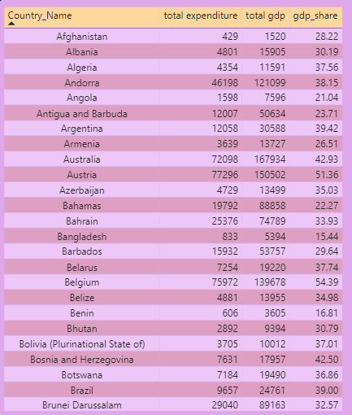

1. Calculate the average health expenditure per capita for each country/region.

expenditure per capita = divide(HealthExpenditureSummary[Total_Expenditure],HealthExpenditureSummary[Total_Population])

// This DAX function returns the health expenditure per capita. This is further represented by following preview.

